HIGH LEVEL DESIGN DOCUMENT:

**Document Version:** 1.0

**Date:** 24/02/2024

**Prepared By:** Sushruth thigulla.

Change Record

|  |  |  |  |
| --- | --- | --- | --- |
| **Revision** | **Date** | **Author** | **Changes** |
|  |  |  |  |
|  |  |  |  |
|  |  |  |  |

CONTENTS:

1. Introduction
   1. what is HLD?
   2. features
   3. overview
2. General Description
   1. Product description
   2. Software and tools used.
   3. General constraints
3. Design
   1. general design of hld.
   2. Flow chart of project.
   3. Component description.

### **Security Considerations**

### **Deployment Strategy**

### **Conclusion**

Introduction:

* 1. what is HLD?

**High-level design** (HLD) explains the architecture that would be used to develop [a system](https://en.wikipedia.org/wiki/Systems_development_life_cycle). The architecture diagram provides an overview of an entire system, identifying the main components that would be developed for the product and their interfaces. The HLD can use non-technical to mildly technical terms which should be understandable to the [administrators](https://en.wikipedia.org/wiki/System_administrator) of the system. In contrast, [low-level design](https://en.wikipedia.org/wiki/Low-level_design) further exposes the logical detailed design of each of these elements for use by engineers and [programmers](https://en.wikipedia.org/wiki/Programmer). HLD documentation should cover the planned implementation of both software and hardware.

Design overview:

A high-level design provides an overview of a system, product, service, or process.

Such an overview helps supporting components be compatible to others.

The highest-level design should briefly describe all platforms, systems, products, services, and processes that it depends on, and include any important changes that need to be made to them.

In addition, there should be brief consideration of all significant commercial, legal, environmental, security, safety, and technical risks, along with any issues and assumptions.

The idea is to mention every work area briefly, clearly delegating the ownership of more detailed design activity whilst also encouraging effective collaboration between the various project teams.

Today, most high-level designs require contributions from a number of experts, representing many distinct professional disciplines.

Finally, every type of end-user should be identified in the high-level design and each contributing design should give due consideration to [customer experience](https://en.wikipedia.org/wiki/Customer_experience).

* 1. Features

The amazon application contains many products, provides the customers a wide range of services. The services required some features to help them out.

The features that we are implementing in this application are as follows:

1.Login

2.Register

3.Deals of day

4.Electronics

5.Cart

All the above features need to be added into the project of amazon application and that makes the application more user friendly to the customers/users and makes it less complicated.

* 1. Overview:

The high-level document for the amazon application with all the features like login, register, deals of day, electronics, cart will be much needed for the application to be efficient to be working.

The features above given have the importanceindividually, each feature add on the value for the application and fills the business needs as well as the customer needs , provides them with user friendly interface .

2. General description

2.1 product description:

The product here named as “Amazon application” is an e-commerce website which has a wide variety of the products like clothes, accessories, mobiles, laptops, etc. which we can buy online. It also has the payment window which we can pay through online money and we have UPI payment for the customers through different UPI platforms like phone pe, google pay ,UPI id and also has the card payment.

We also have the options to search and filter between different categories and products according to their requirement. so, this application gives the customers the comfort of easy and flexible buying and finding the products.

2.2 Tools used:

Database:

We used the my SQL database which have all the data of tables related to the users and their credentials , products, payments etc

Spring boot:

The operations for the backend and also the required microservices are created using the spring boot with the help of the maven as the build tool.

Postman:

The verification of the different http method like get, post , put etc that are used in the microservices can be done using the postman.

Visual studio:

The frontend part of the project or for the features that we are implementing is done using the angular projects that we create and implement in the visual studio. This makes our browser screens ready.

2.3 General constraints:

Certainly! In project management, **constraints** are the general limitations that impact a project’s execution. Let’s explore some common examples:

1. **Cost Constraint**: This refers to the budget allocated for the project. As a project manager, accurately estimating costs during the planning phase is crucial.
2. **Time Constraint**: Managing the available time for project execution is essential. Creating a detailed schedule with defined timelines for project tasks ensures efficient time management.
3. **Scope Constraint**: The project’s scope defines the expected outcome. Any deviation from the defined scope can impact the project’s success.
4. **Quality Constraint**: Ensuring consistent quality throughout the project is vital.
5. **Resource Constraint**: Resources such as labour, materials, and equipment play a crucial role.
6. **Risk Constraint**: Identifying and mitigating risks is critical.

3. Design

3.1 general design of HLD:

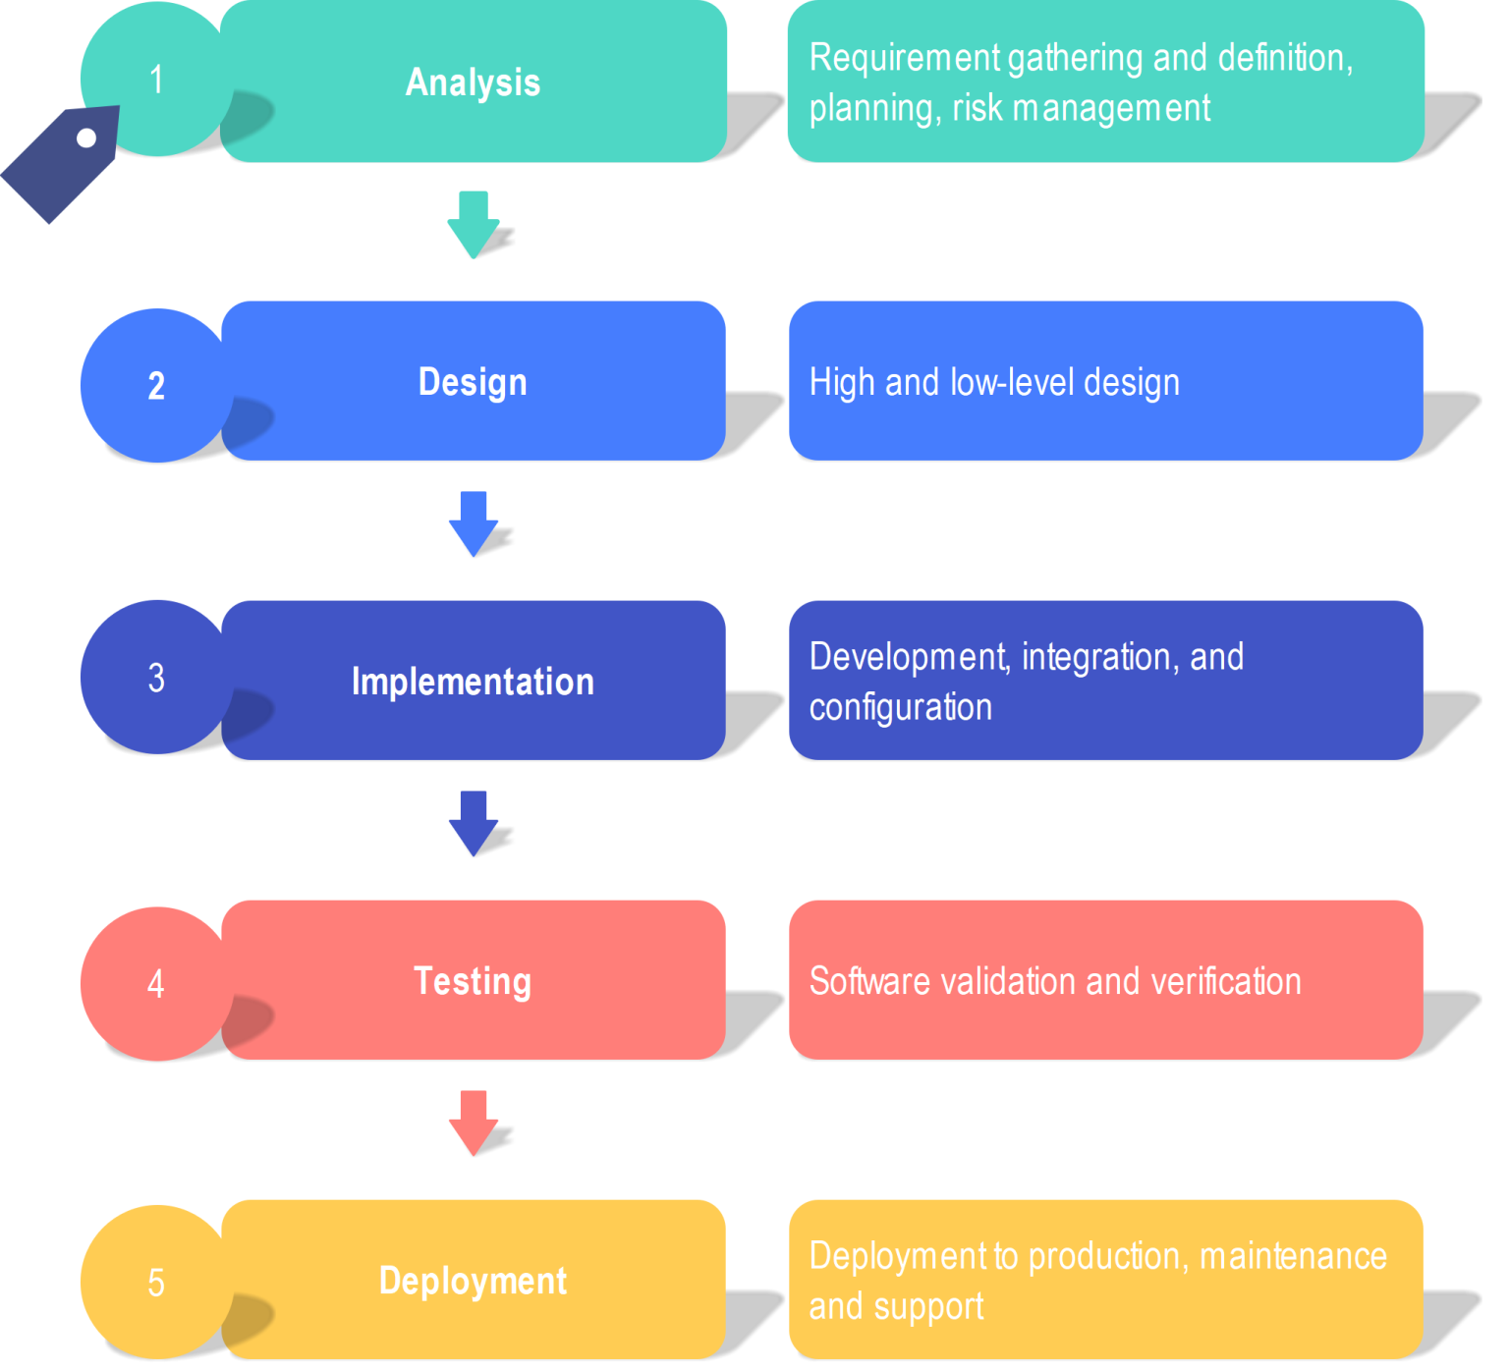

3.2 Flow chart of the project:

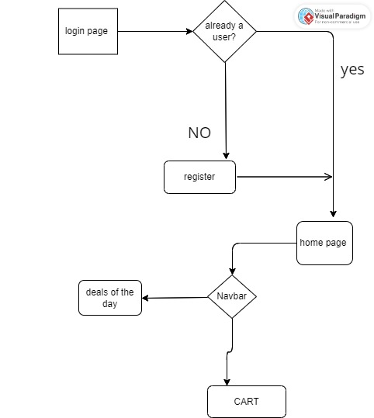

3.3 components description:

1. Login component:

This component shows the login screen for the users to login into application. This page has the fields like username, password, forgot password sections etc.

2. Register component:

This component helps to register if the user are not a member of the user database. It has the fields like username, password, confirm password, mobile number etc

3. Electronics:

This component has the different electronic devices such as mobiles, laptops, earbuds, chargers etc. this component helps in the getting and finding the all the electronic devices at one go.

4. Deals of day:

The day to day deals are being updated into this section of the application. This as the daily discount products , hour based deals etc.

1. Cart

This section of the application helps for the users to add their products into their cart, so that they can be proceeded to buy the products if they needed and overall cost of product and address that to be selected are shown in this section.

### **4. Security Considerations**

Security will be paramount in the design and implementation of the Amazon-like application, with measures in place to protect user data, authenticate users securely, and ensure secure payment processing. Encryption, authentication mechanisms, authorization policies, and compliance with industry standards such as PCI DSS will be implemented to safeguard user information and maintain the integrity of the platform.

### **6. Deployment Strategy**

application will be deployed using containerization with Docker for packaging and Kubernetes for orchestration, enabling seamless scaling, deployment, and management of containerized microservices. Continuous Integration/Continuous Deployment (CI/CD) pipelines will be implemented to automate the deployment process, ensuring rapid delivery of updates and enhancements to the platform.

### **7. Conclusion**

The Amazon-like application represents a groundbreaking solution to meet the evolving needs of modern consumers in the digital e-commerce landscape. By offering a comprehensive platform with user-friendly features, robust architecture, and stringent security measures, the application aims to redefine the shopping experience and become the go-to destination for users seeking culinary delights at their fingertips.